LAB-DAY-1

DWDM date:16/08/2023

NAME:SARAVANAVELU.D REGNO:192224249

1.Addition:

Input:

num1=as.integer(readline(prompt="enter the num1:"))

num2=as.integer(readline(prompt="enter the num2:"))

sum=num1+num2

print(sum)

Output:

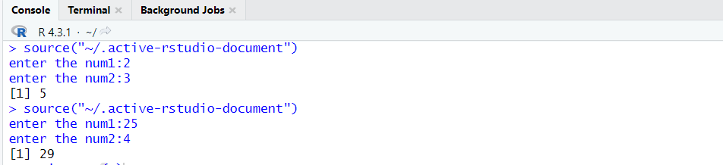

2.Mean

Values: (12,7,3,4.2,18,2,54,-21,8,-5)

Input: # Create a vector.

x <- c(12,7,3,4.2,18,2,54,-21,8,-5)

# Find Mean.

result.mean <- mean(x,trim = 0.3)

print(result.mean)

Output:

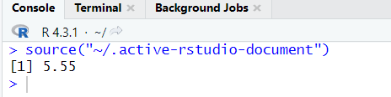

3.Bar plot

Input:

H<- c(12,35,54,3,41)

barplot(H)

Output:

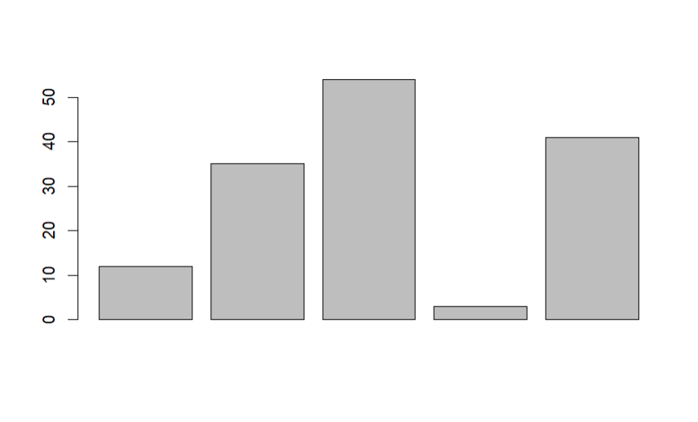

4.Box plot:

Input:

b <- c(10,12,13,14,17,19,20,30,50,70,90,100)

print(boxplot(b,col="green"))

Output:

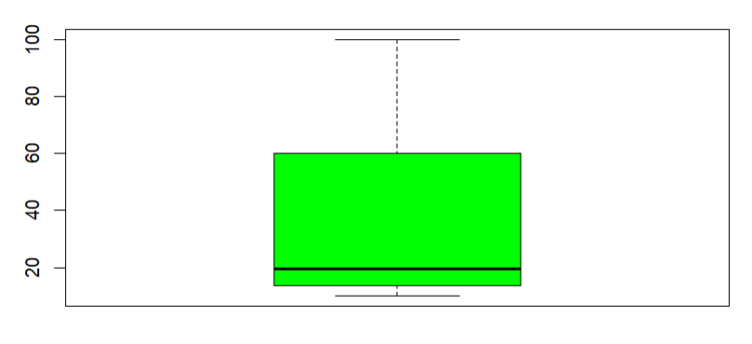

5.Decision Tree:

Input:

# Load the party package. It will automatically load other

# dependent packages.

library(party)

# Create the input data frame.

input.dat <- readingSkills[c(1:105),]

# Give the chart file a name.

png(file = "decision_tree.png")

# Create the tree.

output.tree <- ctree(

nativeSpeaker ~ age + shoeSize + score,

data = input.dat)

# Plot the tree.

plot(output.tree)

# Save the file.

dev.off()

